**BCVD1007 – Full Stack Development II – Lab 8**

* Objects

**Developer Note:**

* Use the web documents and window web api

References:

<https://developer.mozilla.org/en-US/docs/Web/API/Document>

**Exercise 1:**

Create a script file **Ex1.js** with the following requirements

* Create a function named findFacts that will take a city object as an parameter
* The function will output the values in string format to the console

The output should be as follows:  
  
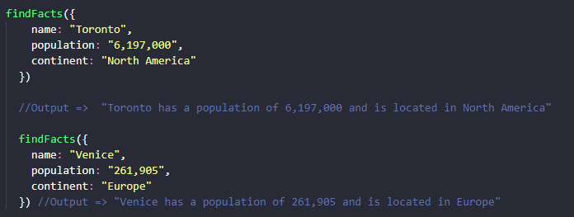

**Exercise 2:**

Create a script file **Ex2.js** with the following requirements

* Create a function named getKeyValuePairs that will take a object as an parameter
* Returns the keys and values as separate arrays
* The keys and values may be in the same original order

The output should be as follows:

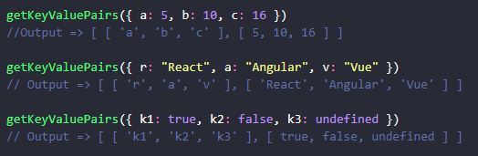

**Exercise 3:**

Create a script file **Ex3.js** with the following requirements

* Use the Object ***Factory Pattern*** to create an object
* Create a function named **product** that will take string parameters **name and price**
  + The function will create an object with these two properties
  + The object will have an internal method/function to get the info of the product
    - returning the name and price object properties when invoked

The output should be as follows:

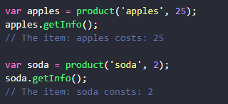

**Exercise 4:**

Create a script file **Ex4.js** with the following requirements

* Use the ***Object Constructor Pattern*** to create an object
* Create a function named **Car** that will take a object as an parameter
  + The object argument have brand and model as keys
  + There will be two internal methods/functions
    - getBrand returns the brand value
    - getModel returns the model value

The output should be as follows:

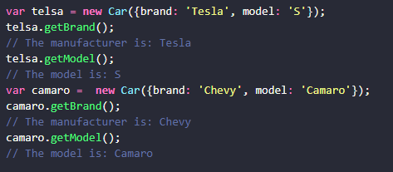

**Challenge:**

Create a script file **Challenge.js** with the following requirements

1. Create function hasFreeShipping that takes an object as a parameter
   1. The function will calculate when the value is over 50 and return true/false

Try to do this logic in one or two lines of code

